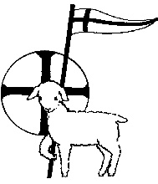

The Parish Church of
St John the Baptist, Tisbury

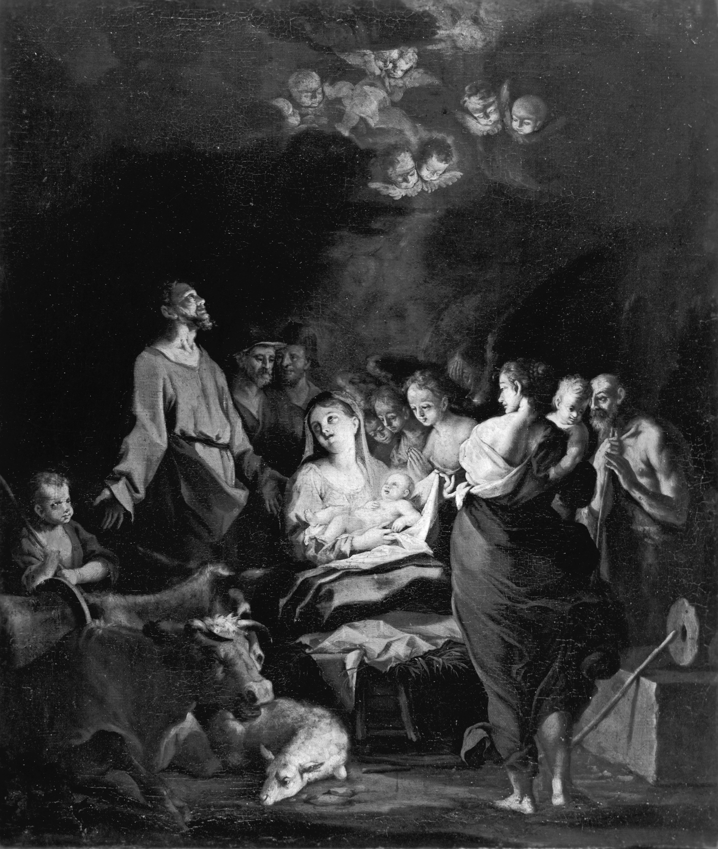

Festival of Lessons and Carols

Monday 19th December 2016
7.30 pm

Welcome to this annual Festival of Lessons and Carols.

This year’s celebration is told through a traditional set of readings devised by Archbishop Benson when he was Bishop of Truro for use in that cathedral. It was later adapted by the Very Revd Eric Milner White in 1918, then Dean of King’s College Chapel, Cambridge. It is that framework that has been widely adopted ever since, and used in the annual Christmas Eve Carol Service broadcast from King’s College.

For the First Lesson we go right back to Adam and Eve’s encounter in the Garden of Eden, and continue in the subsequent lessons with the foretelling of Christ’s birth, the story of the birth itself, and the visits of shepherds and wise men. The sequence culminates with the familiar reading from St John’s Gospel; The Word was made flesh and dwelt among us.

As well as all the old favourites, the music includes one contemporary piece and a well-known choral work – the opening of Vivaldi’s Gloria in D which follows the Seventh Lesson in which the shepherds encounter the angels praising God. The contemporary piece is from the pen of the Scottish composer James MacMillan. “O radiant dawn” is a setting of the Great “O” antiphon for the 21st December.

The service will proceed without announcement. The lessons and prayers are read by representatives from the local community. Please stand where indicated to sing the hymns.

ORDER OF SERVICE

Stand as the choir and ministers process to the St Andrew’s Chapel

SOLO Once in royal David’s City
Stood a lowly cattle shed,
Where a mother laid a baby
In a manger for his bed;
Mary was that Mother mild,
Jesus Christ her little child.

CHOIR He came down to earth from heaven
Who is God and Lord of all,
And his shelter was a stable
And his cradle was a stall;
With the poor and mean and lowly
Lived on earth our Saviour holy.

ALL And through all his wondrous childhood
He would honour and obey,
Love and watch the lowly maiden,
In whose gentle arms he lay:
Christian children all must be
Mild, obedient, good as he.

For he is our childhood’s pattern,
Day by day like us he grew,
He was little, weak and helpless,
Tears and smiles like us he knew:
And he feeleth for our sadness,
And he shareth in our gladness.

And our eyes at last shall see him,
Through his own redeeming love,
For that child so dear and gentle
Is our Lord in heaven above:
And he leads his children on,
To the place where he is gone.

Not in that poor lowly stable
With the oxen standing by,
We shall see him; but in heaven
Set at God’s right hand on high:
Where like stars his children crowned
All in white shall wait around.

Words: Mrs CF Alexander Music: HJ Gauntlett

The Vicar welcomes the congregation before continuing with a Bidding Prayer and The Lord’s Prayer

Our Father who art in heaven
hallowed be thy name,
thy kingdom come,
thy will be done on earth as it is in heaven.
Give us this day our daily bread,
and forgive us our trespasses,
as we forgive those who trespass against us.
And lead us not into temptation,
but deliver us from evil,
for thine is the kingdom,
the power and the glory,
for ever and ever, Amen.

Sit as the choir sings

Ding dong! merrily on high in heav’n the bells are ringing
Ding dong! verily the sky is riv’n with angels singing.
Gloria, Hosanna in excelsis.

E’en so here below below, let steeple bells be swungen,
And i-o, i-o, i-o by priest and people sungen.
Gloria, Hosanna in excelsis

Pray you dutifully prime your matin chime ye ringers,
May you beautifully rime your evetime song ye singers.
Gloria, Hosanna in excelsis

Words: G.R Woodward Music: French trad arr Charles Wood

THE FIRST LESSON: Genesis 3, v 8-14
God announces in the Garden of Eden that the seed of woman shall bruise the serpent’s head.

Remain seated as the choir sings

Adam lay ybounden, bounden in a bond,
Four thousand winter thoughte he not too long;
And al was for an apple, an apple that he took,
As clerkes finden writen in hire book.
Ne had the apple taken been, the apple taken been,
Ne had nevere Oure Lady ybeen hevene Queen.
Blessed be the time that apple taken was:
Therfore we mown singen Deo Gratias.

Words: anon 15th century Music: Boris Ord

THE SECOND LESSON: Genesis 22, v 15-18
God’s promise to faithful Abraham that in his seed shall the nations of the earth be blessed.

All stand to sing

Joy to the world! The Lord has come;
Let earth receive her King,
Let every heart prepare him room
and heav’n and nature sing,
and heav’n and nature sing,
and heav’n, and heav’n and nature sing.

Joy to the earth! The Saviour reigns;
Your sweetest songs employ,
While fields and streams and hills and plains
repeat the sounding joy,
repeat the sounding joy
repeat, repeat the sounding joy.

He rules the world with truth and grace,
And makes the nations prove
the glories of his righteousness,
the wonders of his love, the wonders of his love,
the wonders, the wonders of his love.

Words: Isaac Watts Music: Lowell Mason
Sit

THE THIRD LESSON: Isaiah 9, v 2, 6-7
The prophet foretells the coming of the Saviour.

Remain seated as the choir sings

O radiant dawn.
Splendour of eternal Light,
Sun of Justice.
Come, shine on those who dwell in darkness
and the shadow of death.

Isaiah had prophesied
‘The people who walked in darkness
have seen a great light;
upon those who dwelt in the land of gloom
a light has shone.’

O radiant dawn.
Splendour of eternal Light,
Sun of Justice.
Come, shine on those who dwell in darkness
and the shadow of death.
Amen.

Words: “O” Antiphon for 21st December Music: James MacMillan

THE FOURTH LESSON: Isaiah 11, v 1-9
The peace that Christ will bring is foreshown.

All stand to sing

O little town of Bethlehem
How still we see thee lie!
Above thy deep and dreamless sleep,
The silent stars go by;
Yet in thy dark streets shineth
The everlasting light;
The hopes and fears of all the years
Are met in thee tonight.

O morning stars together
Proclaim the holy birth,
And praises sing to God the King
And peace to all the earth.
For Christ is born of Mary
And, gathered all above,
While mortals sleep, the angels keep
Their watch of wondering love.

How silently, how silently,
The wondrous gift is given!
So God imparts to human hearts
The blessings of his heaven.
No ear may hear his coming;
But in this world of sin,
Where meek souls will receive him, still
The dear Christ enters in.

O holy child of Bethlehem
Descend to us, we pray;
Cast out our sin and enter in;
Be born in us today!
We hear the Christmas angels
The great glad tidings tell:
O come to us, abide with us,
Our Lord Emmanuel.

Words: Phillips Brooks Music: H Walford Davies
Sit

THE FIFTH LESSON: St Luke 1, v 26-38
The angel Gabriel salutes the Virgin Mary.

Remain seated as the choir sings

A maiden most gentle and tender we sing:
Of Mary the mother of Jesus our King.
Ave, Ave, Ave Maria.

How blessed is the birth of her heavenly child,
Who came to redeem us in Mary so mild.
Ave, Ave, Ave Maria.

The Archangel Gabriel foretold by his call
The Lord of creation and Saviour of all.
Ave, Ave, Ave Maria.

Three kings came to worship with gifts rich and rare,
And marvelled in awe at the babe in her care.
Ave, Ave, Ave Maria.

Rejoice and be glad at this Christmas we pray;
Sing praise to the Saviour, sing endless ‘Ave.’
Ave, Ave, Ave Maria.

Words: paraphrased from the Venerable Bede by Andrew Carter Music: Andrew Carter

THE SIXTH LESSON: St Matthew 1, v 18-23
St Matthew tells of the birth of Jesus.

All stand to sing

Unto us is born a Son,
King of quires supernal:
See on earth his life begun,
Of lords the Lord eternal,
Of lords the Lord eternal.

Christ, from heav'n descending low
Comes on earth a stranger;
Ox and ass their owner know,
Be-cradled in the manger,
Be-cradled in the manger.

MEN This did Herod sore affray,
And grievously bewilder,
So he gave the word to slay,
And slew the little childer,
And slew the little childer.

WOMEN Of his love and mercy mild
This the Christmas story;
And O that Mary's gentle child
Might lead us up to glory,
Might lead us up to glory!

O and A, and A and O,
Cum cantibus in choro,
Let our merry organ go,
Benedicamus Domino,
Benedicamus Domino.

Words: trad tr GR Woodward Music: Piae Cantiones arr Sir David Willcocks

Sit

HANDBELLS ARE RUNG
Remain seated as we all sing

Silent night, holy night,
All is calm, all is bright,
Round the virgin mother and her child,
Holy infant so tender and mild,
Sleep in heavenly peace,
Sleep in heavenly peace.

Silent night, holy night,
Shepherds quail at the sight,
Glory streams from heaven afar,
Heavenly hosts sing 'Alleluia:
Christ the Saviour is born,
Christ the Saviour is born'.

Silent night, holy night,
Son of God, love's pure light:
Radiant beams your holy face,
With the dawn of saving grace,
Jesus, Lord, at your birth,
Jesus, Lord, at your birth.

Words: J Mohr Music: Franz Grűber, arr David Iliff

THE SEVENTH LESSON: St Luke 2, v 8-16
The shepherds go to the manger.

Remain seated as the choir sings

Gloria! In excelsis Deo.
Glory to God in the highest.

Words: The traditional Latin Mass Music: Antonio Vivaldi

THE EIGHTH LESSON: St Matthew 2, v 1-11
The wise men are led by a star.

All stand to sing “Adeste fideles” during which a Collection will be made for the work of the Tisbury Christian Council.

O come all ye faithful, joyful and triumphant,
O come ye, O come ye to Bethlehem.
Come and behold him, born the king of angels,
O come let us adore him,
O come let us adore him,
O come let us adore him,
Christ the Lord.

God of God, Light of Light,
Lo! He abhors not the virgin’s womb.
Very God, begotten not created,
O come let us adore him…

See how the shepherds, summoned to his cradle,
Leaving their flocks draw nigh with lowly fear.
We too will thither bend our joyful footsteps,
O come let us adore him…

Lo! Star-led chieftains, Magi, Christ adoring,
Offer him incense, gold and myrrh;
We to the Christ Child bring our hearts’ oblation:
O come let us adore him…

Sing choirs of angels, sing in exultation,
Sing all ye citizens of heaven above,
“Glory to God, in the highest”
O come let us adore him…

Yea Lord we greet thee, born the happy morning,
Jesu to thee be glory giv’n.
Word of the Father, now in flesh appearing:
O come let us adore him…

Words & Music: JF Wade and others Descant: Sir David Willcocks
Remain standing

THE NINTH LESSON: John 1, v 1-14
St John unfolds the great mystery of the Incarnation.

Hark the herald angels sing
Glory to the new-born King;
Peace on earth, and mercy mild
God and sinners reconciled.
Joyful all ye nations rise,
Join the triumph of the skies;
With the angelic host proclaim,
Christ is born in Bethlehem.
Hark the herald angels sing
Glory to the new born King.

Christ by highest heaven adored,
Christ the everlasting Lord,
Late in time behold him come,
Offspring of a virgin’s womb!
Veiled in flesh the godhead see!
Hail the incarnate deity!
Pleased as man with man to dwell,
Jesus, our Emmanuel!
Hark the herald angels sing
Glory to the new born King.

Hail the heaven-born Prince of Peace!
Hail the Sun of Righteousness!
Light and life to all he brings,
Risen with healing in his wings
Mild he lays his glory by,
Born that man no more may die,
Born to raise the sons of earth.
Born to give them second birth.
Hark the herald angels sing
Glory to the new born King.

Words: C Wesley/T Whitefield/M Madan and others Music: Felix Mendelssohn
Remain standing

THE COLLECT FOR CHRISTMAS EVE
Almighty God, you made us glad with the yearly remembrance of the birth of your son Jesus Christ; grant that as we joyfully receive him as our redeemer, so may we with sure confidence behold him when he shall come to be our Judge, who is alive and reigns with you in the unity of the Holy Spirit, one God, now and for ever, Amen.

THE BLESSING

The Lord be with you
And with thy spirit

May the joy of the angels, the eagerness of the shepherds, the perseverance of the wise men, the obedience of Joseph and Mary and the peace of the Christ child be yours this Christmas.
Amen.

And the blessing of God Almighty, the Father, the Son and the Holy Spirit, be upon you and remain with you now and always.
Amen.

Please remain standing as the choir and ministers leave the church.

The Tisbury Christian Council (and the churches it represents)
wishes you and those dear to you
A BLESSED AND HAPPY CHRISTMAS !!

Please come to the Hinton Hall for mulled wine and mince pies.

See back cover for Christmas services in the Tisbury churches.

Any copyright words reproduced here are printed under CCLI licence 964767

CHRISTMAS SERVICES IN TISBURY

Roman Catholic - The Church of the Sacred Heart
Saturday 24th Dec Mass of the Night 10.00 pm
Sunday 25th Dec Parish Mass 9.00 am

Roman Catholic - All Saints Chapel, Wardour Castle
Sunday 25th Dec Sung Mass 11.00 am

Tisbury Methodist Church
Friday 25th Dec Christmas Day service 9.30 am

The Parish Church of St John the Baptist
www.tisburyparishchurch.org
Saturday 24th Dec Midnight Mass 11.30 pm
The First Eucharist of Christmas
Sunday 25th Dec Holy Communion (BCP) 8.00 am
Parish Communion 9.30 am

Front cover
The Adoration of the Shepherds
Ignaz Stern 1679 – 1748
Credit: Walters Art Museum, Baltimore.

